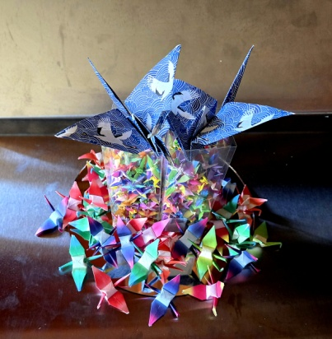
Cranes & Memorials
My twin towers are full of tiny oriami cranes folded from 1 1/2inch papers, with 27 folds each. Around the bottom of the towers are more cranes (still 27 folds in each cranes) and topped by two “traditionally” folded larger cranes. In all ,the folds , remembering each of those who lost their lives in the 911 tragedy 25 years ago both in the towers, a field in Pennsylvania, and at the Pentagon.
Folded cranes were folded from people around the world and sent to NY in 2001 and hang there still. For websites that feture stories about the cranes still folded, and the memorial with cranes, created round the world still in 2026 25 years later: see some links below.
https://www.yahoo.com/news/us/articles/25-years-ago-two-strangers-090030747.html
A chapel near ground zero was a relief center after 9/11. Now, an exhibit honors its victims. Over in 102 minutes? Well yes the attacks but 7000 Americans who died in the wars that came next…..
NEW YORK (RNS) — A new origami installation strings 2,977 paper cranes: one for each person killed in the attacks. The 'Ever Present' exhibition also features artifacts left there in the months after 9/11. The “Ever Present” exhibition of origami paper cranes is installed at St. Paul’s Chapel, Thursday, Sept. 3, 2026, in New York City. (RNS photo/Fiona André)Fiona André September 9, 2026 at 6:00 p.m. ET
NEW YORK (RNS) — In the months after 9/11, St. Paul’s Chapel, a small, undamaged church sitting 100 yards from where the Twin Towers once stood, quickly turned into a relief center for recovery workers. Known as the “Little Chapel That Stood,” the church kept its doors open 24/7 for nine months, providing food, prayers and support to responders in between shifts.
. 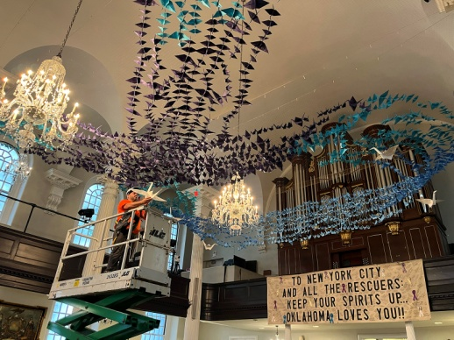
https://religionnews.com/2026/09/09/the-little-chapel-that-stood-trinitys-st-pauls-remembers-9-11-with-art-installation/

https://www.youtube.com/watch?v=tHj2_Ftm7C8 For you to learn to fold a crane

https://www.friendsjournal.org/friends-academy-students-fold-2977-peace-cranes-to-honor-9-11-victims/

https://sightmagazine.com.au/uncategorized/a-chapel-near-ground-zero-was-a-relief-centre-after-9-11-now-an-exhibit-honours-its-victims/

https://store.911memorial.org/products/paper-crane-ornament

Sadako the true story and the paper cranes
https://archive.org/details/sadakothousandpa00coer_0 

